Talk to Me: An AI Therapist

AI-Driven Empathy in Mental Health Care

|  |  |  |
| --- | --- | --- |
| Prof. Sagar Badjate  *Dept. of Information Technology*  *SVKM’s IOT, Dhule*  Sagar.Badjate@svkm.ac.in | Dhanashri Saner  *Dept. of Information Technology SVKM’s IOT, Dhule*  Sanerdhanashri2003@gmail.com | Anuj Deshmukh  *Dept. of Information Technology*  *SVKM’s IOT, Dhule*  anujdeshmukh21jan@gmail.com |
|  |  |  |

Gaurav Baviskar Darshan Sonar

*Dept. of Information Technology Dept. of Information Technology*

*SVKM’s IOT, Dhule SVKM’s IOT, Dhule*

baviskargaurav08@gmail.com sonardarshan480@gmail.com

***Abstract*—** **AI could serve as a tool to assist with depression. Depression is a widespread mental disorder that affects millions of individuals around the world and can disrupt one’s life in a variety of ways. However, multiple elements including the shortage of professionals, their high cost, and the stigma connected with seeing them make receiving professional help nearly impossible. Therefore, there is an essential need for a more available source of compassionate psychological support. The present study studies the development and use of an AI-based virtual therapist that could save people affected by depression. A depression therapist AI might become a link to the real-life mental health services, providing accessible information, caring attitude, and encouragement**. **However, the project also highlights that it is crucial to consider user safety, ethics, and the necessity to regard AI as an extra tool for the provision of services rather than a replacement for human aid. In conclusion, the article highlights the importance of ethical design of AI in sensitive areas and contributes to the growing concern for the connection between AI and mental health.**

***Index Terms*—Depression, Mental health, Professional support, Stigma, Cost, Availability, Virtual therapist**

I. INTRODUCTION

Depression is a complicated mental illness, but it heavily impacts the lives of people, their families, and societies. The World Health Organization estimates 322 million cases around the world, which makes it a crucial international health issue [1]. The comprehensive prevalence of the problem shows that individuals, irrespective of age, sex, or socioeconomic status, are susceptible to this condition. Despite the instinctive understanding that this ailment is severe and needs professional help, many hurdles prevent people from getting the required treatment [7]. There are several reasons why seeking immediate help is often not recommended, which include a stigma, economic constraints, and a lack of access to mental health care [4]. The pressing problem also makes it possible to consider the development of the developing field of artificial intelligence, or AI as a novel approach to overcoming obstacles in treating depression.

This is done through the deployment of AI technology such as Natural Language Processing, and machine learning to create AI-based virtual Therapists; they provide affordable and emotionally sensitive assistance to individuals suffering from depression [2]. Providing these AI advisors to users recognizes proper therapy conversations in real-time, allowing them access to valuable materials and reducing time in a sympathetic presence at their convenience [4]. The authors wrote the following on the usage of online therapists to combat people suffering from depression in the absence of the mental health care system. AI Therapists will seek to reduce the depression burdens of people suffering from depression by allowing them to have sympathetic conversations. Still, caution and ethics should never be disregarded while pursuing technological advancements [1][5].

Our work is devoted to the creation and application of an AI virtual therapist, a friendly digital buddy with empathetic chatting abilities to converse and sympasize and provide valuable insights. As it is presupposed by the job, the main application of this AI friend is to help a person in need. This AI friend is designed to enhance the existing mental health situation by offering accessible and private support for anyone in need, not to substitute human therapists. The study covers many topics on this subject, from the technology of our AI therapist to the ethical issues which arise in rendering services in the sphere of mental health [3]. This research also puts emphasis on the idea that AI should serve as an extra doctor, an opportunity to improve healthcare, and a resting place on the path of recovery. All the components, methods, results, and the practical implications of our research are discussed in the following sections and contribute significantly to the general conversation in terms of AI-based mental health assistance [12]. This introduction that outlines general considerations about depression as a prevalent medical problem, the deficiencies of the existing supportive mechanisms, and the aim of the research to investigate AI as a mean to respond to these deficiencies, introduces this research paper [7].

II. LITERATURE REVIEW

Depression is a worldwide health crisis in which people experience persistent emotions of despair and despair, as well as loss of interest in daily life. Psychotherapy, pharmaceutical, and other clinical paradigms are the standard therapies for depression [5]. These treatments, however, frequently face obstacles concerning expense, accessibility, and the widespread stigmatization of depression treatment.

In light of these complications, application-based artificial intelligence AI and natural language processing NLP have become increasingly appealing alternatives. Specifically, as noted by Fitzpatrick et al., conversational agents driven by AI, also recognized as chatbots or virtual therapists, have become feasible avenues for providing mental health assistance bin et al. They can be used to supplement current therapy methods since they are available 24 hours a day, seven days a week and guarantee anonymity [2][7][8]. Moreover, the successes of chatbots and virtual therapists for mental health have already been investigated in numerous trials.

Indeed, Fitzpatrick et al. completed a study to investigate the effectiveness of AI chatbots in providing help to individuals showing gloominess and anxiety symptoms. It was found that as a result of their contact with the chatbot, people felt a sense of relief and a desire to visit a specialist [1]. Another work, which was conducted by Ly et al. , concluded that the utilization of AI-based virtual therapists was significantly correlated to the reduction of depressed symptoms. Both papers showed how modern technologies can help provide mental health services easily and quickly.

Although the literature sheds light on the advantages of AI-driven mental health care, it is crucial to discuss the drawbacks and moral issues. Concerns were raised by Barak et al. (2008) about the possibility that AI therapists may oversimplify difficult emotional problems, which would leave users unhappy [3][7]. It's important to tread carefully when navigating ethical issues including user privacy and resolving crisis circumstances (Luxton et al., 2011).

To sum up, research into AI-powered mental health support is mostly positive so far, with the focus on the relieved symptoms and improved accessibility. However, it is characterized by a keen awareness of the importance of ethical thinking, responsible development, and a knowledge of AI’s role as a small adjunct to mental health care. Due to the urgent need to improve the quality of mental health care, the research into the interface between artificial intelligence and mental health support has become more dynamic recently. This body of research should be analyzed to identify the progress made in the field and its possible weaknesses, and review it to the extent necessary for our project, developing an AI-based virtual Therapist for depressed individuals. Hence, prior authors’ studies need to be evaluated accomplished in the research of artificial intelligence within the field of mental illness, counseling, and psychology to form a theoretical foundation for a developed project [5][11].

Artificial Intelligence in Mental Health: a growing corpus of scientific papers has expressed high hopes for artificial intelligence in improving mental health care. AI-based therapies have already demonstrated efficacy in a range of fields, from the prognosis of depressive episodes to therapeutic facilitation [2]. The usage of machine learning algorithms to detect individuals at risk and the employment of chatbots and virtual therapists to offer psychological cares are a few trial cases.

Stigma and Accessibility: the difficulty of accessibility to psychiatric healthcare is also frequently raised as a common theme across the literature. Public shame on mental health disease, which frequently acts to prevent individuals from obtaining care, and the cost and lack of geography of professional care are two factors. Artificial intelligence solutions can help undermine these barriers and reduce the stigma by offering private, judgment-free, accessible 24/7 assistance [3][4].

The lack of previous studies In conclusions, the previous studies were conducted in the literature to prove the same aim of this researches. Considering new studies: The use of virtual therapists and other forms such as chatbots in mental health help is beneficial. The conversation held in a therapeutic way releases the feeling of understanding from the other end [2].

The research suggested that social feedback indicated that the users found virtual therapists as “solution” providers of help. Ethical considerations: AI application in mental health has several ethical complexities. Issues such as data protection, consent, AI’s ability to identify and respond to people who show signs of suicide flows are the main. Algorithms used in health should be designed to safeguard the well-being of the users.

Another point of limitation or difficulty: “the complexity of the understanding and empathy real therapists often offer may not be something very replicable by simple chatbots or virtual therapists” [4] . It requires thoughtful involvement in ethical issues, with one of the t commonly discussed being “AI mistakenly interpreting, or incorrectly managing signals of user distress”.

Regarding one’s gap, the material pays attention to the actuality of AI as a domain in the field of mental health, highly-developed interest, and yet-to-be-explained user experience, technological implementation and so forth. Since these areas have not been explored, it is necessary to fill the gaps for proper AI tools development [3][8].

This reflect highly on the work that we are carrying out in this emerging area. Our efforts are to draw attention to the gaps in research and to extend the dialogue regarding AI in mental health support by developing and implementing an AI Therapist for the depressed [9]. This will also increase access and reduce the negative connotation around.

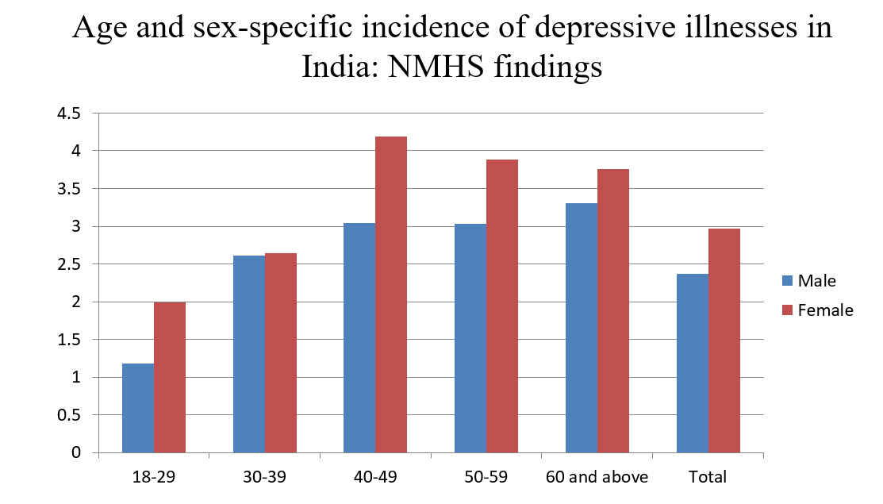

Fig. 2.1. Statistics for India

III. ARCHITECTURE AND METHODOLOGY

The architecture and the technique to create an AI therapist for depression entail several elements that are part of it, we have machine learning, natural language processing, data management, user interface, and ethical issues. The below is the high-level architecture and process overview of our project: Buildings:

The project is relatively simple as it is only required to develop an AI therapist specifically for depressive people.

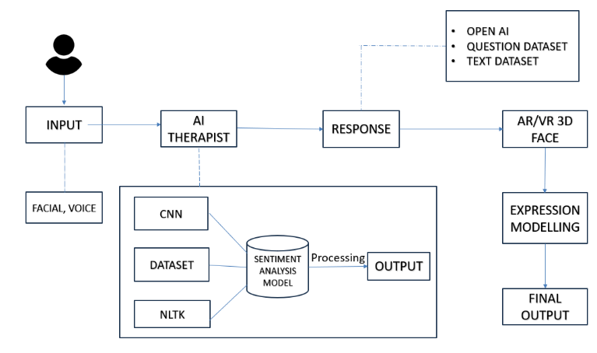

Fig. 3.1. System Architecture

This AI therapist combines several input modalities, allowing consumers to provide it with feedback using speech and face data. Based on the presented input data, a sentimental analysis is carried out by using state-of-the-art technology such as a CNN and a dataset. The system also leverages the Natural Language Toolkit for natural language processing to create all composite activities that can sometimes understand what a user accesses and respond appropriately.

Voice and face data are the primary modality users utilize to communicate with it. Under this two-input approach, depression-related facial cues and verbal expressions are collected. Thus, the user’s emotional state is better understood.

For data processing, this project employs a Convolutional Neural Network and a data set to determine and understand the emotionality of the sad person portrayed. Because the CNN can process images very well, it can discern the features for various emotions based on a person’s expression. Thus, the AI therapist can be more empathetic and aware of the context with this aspect.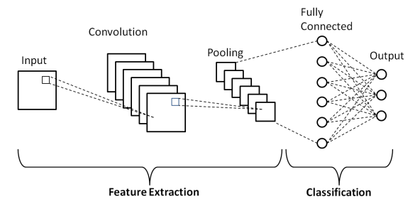

Fig. 3.2. CNN architecture

**Natural Language Processing:** The project employs NLTK’s Natural Language Toolkit to handle spoken language. The AI therapist interprets and analyses the user’s emotional condition through the language primarily thanks to natural language processing to the language spoken input. Question Dataset and API Key: This project employs a question dataset, which is question-based on most activities, substantially indicating the series of questions that the dialogue should be with a depressed person. Based on the user’s voice input, the AI therapist responds utilizing an “Open AI” approach. This influences the interaction style of the AI therapist due to the most spoken conversation.

**3D facial emotion modelling in AR and VR:** The feature of the final stage of the project is a new operating system, 3D facial emotion modelling in AR and VR. In response, the AI therapist gave the user not only the answer, but also the response in three dimensions, that is different attitude – such as joyful or sad expression. This stage is meant to guarantee an experience to a model that could visually show their expressions to more pleasant, communicative, creative, and interesting the user or the depressed individual he communicates with. Maximum Propulsion is a project whose research is to establish an AI therapist utilizing CNN and a dataset to analyse the CNN case.

The final touch is 3D face expression modelling for augmented reality and virtual reality and provides a unique and exciting experience of those in search of depression help. Techniques:

**Data gathering and preparation:** collect and prepare user interactions as text/speech data. This process must be anonymous and secure. NLP model selection and training Lexicon’s experience with depressed people will be used to collect proper NLP models like GPT-3 and BERT. Developing and adjusting the previously picked NLP models to reflect the project’s ultimate goals better.

**Development of the user interface of AI Therapist:** Develop the web interface of the mobile interface that is easy to use when communicating with the AI Therapist. Ensure that the user experience of the interface is straightforward and easy to utilize.

**Development of Ethical Framework:** Develop the AI Therapist an ethical framework for the management of private user information and the ethical requirements for ensuring that the user is protected.

**Training of the Machine Learning Models and the User input Integration**: Use acquired data from the user leads to the continuous development and training of the machine learning models and the integration of the input that the user has over the AI Therapist. Converging resources used to talk to people about mental health: Develop a platform that enables individuals to access the information of resources used when people need to talk to someone concerning their mental health.

**Monitoring and Continuous Improvement:** Regularly check user comments, wellbeing precautions, and exchanges with the AI therapist and make modifications as needed to increase its efficacy and implementation.

IV. COMPARATIVE ANALYSIS

Comparative Analysis: Existing System vs. AI Therapist for Depression.

Table 4.1 Comparative Analysis

|  |  |  |
| --- | --- | --- |
| **Aspect** | **Existing System** | **AI Therapist for Depression** |
| Nature of Support | In-person therapy, hotlines, limited online support | AI-driven, personalized interactions, 24/7 availability |
| Accessibility and Availability | Limited due to geographic constraints | Readily accessible, overcoming geographic barriers |
| Interactivity and Personalization | Limited due to human resource constraints | Personalized, adapts responses based on emotional states |
| Technology Integration | Relies primarily on human intervention | Integrates AI, NLP, emotional understanding |
| Scalability and Consistency | Limited scalability, inconsistent service quality | Scalable, maintains consistency in responses |
| Driven Insights | Limited insights from interactions | Collects data for analysis, monitors user progress |

A full understanding of AI-driven mental health support, such as an AI therapist for depression, can set the stage for alleviating the state of depression in people with timely, accessible, and compassionate care. The following section will compare the AI therapist project with traditional methods of mental health care, emphasizing the principal points of difference and potential advantages.

V. RESULT

Here are the results of our system, showcasing the working of AI therapist or therapist.

def cnn_model():

  model= tf.keras.models.Sequential()

  model.add(Conv2D(32, kernel_size=(3, 3), padding='same', activation='relu', input_shape=(48, 48,1)))

  model.add(Conv2D(64,(3,3), padding='same', activation='relu' ))

  model.add(BatchNormalization())

  model.add(MaxPool2D(pool_size=(2, 2)))

  model.add(Dropout(0.25))

  model.add(Flatten())

  model.add(Dense(256,activation = 'relu'))

  model.add(BatchNormalization())

  model.add(Dropout(0.25))

  model.add(Dense(512,activation = 'relu'))

  model.add(BatchNormalization())

  model.add(Dropout(0.25))

  model.add(Dense(7, activation='softmax'))

  model.compile(

    optimizer = Adam(lr=0.0001),

    loss='categorical_crossentropy',

    metrics=['accuracy'])

  return model

The provided code defines a Convolutional Neural Network model for the sake of identifying face emotions. The model architecture consists of a series of layers. The first two types are the max-pooling layers used for downsampling and those internally contain drop-out layers, which are meant for randomly setting a portion of the input units to zero at each update during training. As a result, the model is guarded against overfitting via adding noise to the internal layers. The convolutional layers are used with rectified linear unit ( ReLU ) activation functions and subsequent batch normalisation for earlier internal activation normalization, which reduces the training epochs compared to the same models without it. The flatten layer is necessary in order to convert 2d feature maps into a 1d vector. The next batch normalisation and drop-out layers and densely connected layer with ReLU activation functions are for deeper learning. Lastly, there are seven neurons on the output layer: one destined for each of the seven facial emotion classes which applies the softmax activation function for multi-class classification. The architecture comes up with the Adam optimizer with the specified learning rate, a categorical cross-entropy loss function for multi-class classification was used, and the evaluation parameter was it accuracy. It will be a good architecture to learn and classify face expressions efficiently in the attempt to recognize facial expressions.

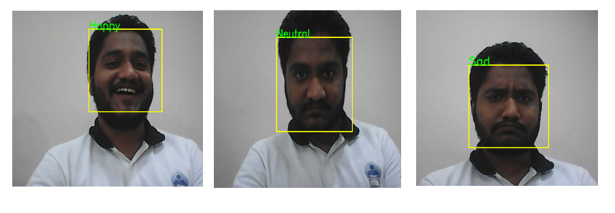

Fig. 5.1. Emotion Recognition using CNN

In the Fig. 5.1 this showing that we are using convolutional neural network to detect the emotion of the user. This part is used in the system for AI therapist to response according to the sentiment analysis.

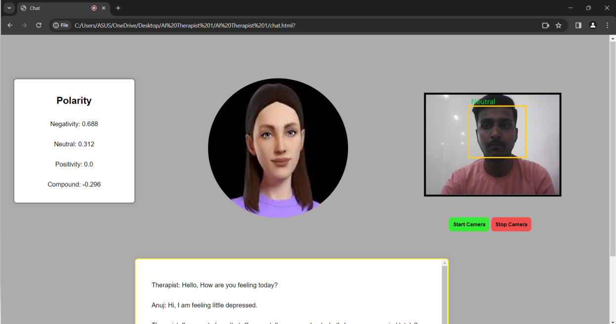

Fig. 5.2. Session Page

This result is showcasing the conversation between the end user and our AI therapist. In this webpage camera is used to detect the facial emotions from real time camera based. The therapist start the conversation and the end user respond with kindness. Afterwards, the AI therapist analyses the text and responses accordingly.

Finally, AI therapist demonstrates the polarity of the dialogue between the end users. Polarity could be found by using the NLTK library. Polarity is a sentiment analysis concerning user-provided voice input’s emotional aspects. Branch of NLP concerns about sentiment analysis and it helps understanding the sentiments, emotions, and opinions in textual data. By using the NLTK framework Natural Language Toolkit we can explore the exciting field of sentiment analysis and identify the polarity of interactions between end users. The “polarity” of the end users can be defined as the sentiment or mood they express through their voice input. NLTK provides a vast variety of resources and methods for text analysis, among them is sentiment analysis. For example, NLTK’s sentiment analysis capabilities enable analysts in arranging text polarity. By polarity, we refer to the fact if the polarity of the sentiment has good or bad vibes or if the text is generally neutral. By analyzing polarity, we can grasp the unstated sentiment in most talks.

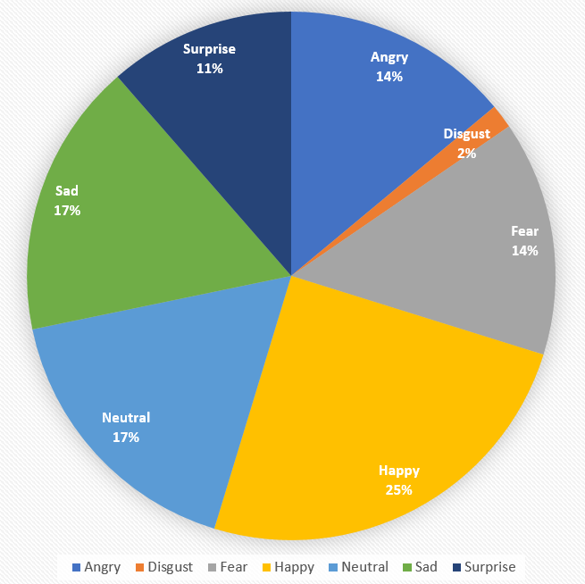

Fig. 5.3. Analysis of result with percentage

The pie chart illustrates the classification outcomes of an AI model trained using a dataset containing various facial expressions. After training, the AI system employs facial parameters such as polarity and sentiments to categorize individuals' expressions. It uses facial coordinates to determine the most appropriate category from the pie chart for each facial expression. This categorization process results in quantifiable data on the distribution of facial expressions across different emotional states, as shown in the chart. Each segment of the pie chart represents the percentage of faces classified into categories such as Happy, Sad, Neutral, Angry, Fear, Surprise, and Disgust. In essence, the chart provides a visual summary of how the AI model interprets and classifies facial expressions from the dataset. This information is crucial for understanding the emotional diversity within the sample and for enhancing the AI system's ability to accurately recognize and respond to various emotional states in therapeutic applications.

VI. CONCLUSION

Accessibility, personalization, and anonymity are the key advantages of the AI therapist project over traditional support. It is important to note an array of the project’s boundaries, including the inability for the AI machine to perfectly mimic the therapeutic relationship with a therapist. The key takeaway is that the AI-powered support, and conventional treatment approaches are supplementary, ensuring that the former serves as a relevant tool through enhancing the accessibility of mental support through regular text interfaces to more depressed patients unaddressed by therapists. Continued research and addressing the mentioned ethics are essential to ensure the ethical and effective use of AI in this field.

This comparison analysis highlights the possible benefits and drawbacks of your AI therapist project and shows how it varies from conventional mental health support. In your research paper, you might go into further detail and include particular data or study findings to back up your analysis.

VII. FUTURE SCOPE

The future of AI depression therapists is promising, with several key considerations. AI depression therapists have great prospects in the future. It is likely that their skills will be significantly expanded thanks to technological progress. In particular, it is the creation of complex AI models that use natural language processing. It can make it possible for the therapists to communicate more gently and better understand the user’s emotions. In addition to this, the inclusion of multimodal interactions like video and audio calls would also be beneficial for the therapy and would increase the relevance of the dialogs. The efficacy of AI therapy could also be improved through personalized CBT exercises and self-help suggestions and treatment plans tailored to the user. Finally, the response of the therapist could be automatically altered depending on the detected user’s emotion thanks to emotion detection technologies.

REFERENCES

1. Victor Hung, Miguel Elvir, Avelino Gonzalez, Ronald DeMara, ”Towards a Method For Evaluating Naturalness in Conversational Dialog Systems,” *2009 International Conference on System,* San Antonio, TX, USA, 2009
2. Tarashankar Rudra, Manning Li, Manolya Kavakli, ”ESCAP: Towards the Design of an AI Architecture for a Virtual Therapist to Tackle Students’ Exam Stress,” 2012 45th Hawaii International Conference on System Sciences,Australia, 2012 Carol Antony, Bestina Pariyath, Seema Safar, Aswin
3. Sahil, Akash R Nair , “Emotion Recognition-Based Mental Healthcare Chat-bots: A Survey ,“ International Conference on IoT based Control Networks and Intelligent Systems ( ICICNIS 2020) *, Kochi 682039, Kerala, India, 2020.*
4. Sushruth P Konapur, Tejas Krishna, Varun G, Uma R, Sarojadevi H, ”Design of a Chatbot for People Under Distress using Transformer Model.,” 2021 2nd Global Conference for Advancement in Technology (GCAT) — 978-1-6654-18362/21/$31.00 ©2021 IEEE, *Bangalore, India. Oct 1-3, 2021*
5. Bhuvan Sharma, Harshita Puri and Deepika Rawat,”Digital Psychiatry – Curbing Depression using Therapy Chatbot and Depression Analysis,” Proceedings of the 2 nd International Conference on Inventive Communication and Computational Technologies (ICICCT 2018) IEEE Xplore Compliant - Part Number: CFP18BAC-ART; ISBN:978-15386-1974-2
6. Liang Zhang, Yan Yang, Jie Zhou, Chengcai Chen , And Liang He, – ” Retrieval-Polished Response Generation for Chatbot ”, Digital Object Identifier 10.1109/ACCESS.2020.3004152. Department of Computer Science, East
7. China Normal University, Shanghai 200062, China Shanghai Key Laboratory of Multidimensional Information Processing, East China Normal University, Sanghai 200241, China 3 Xiaoi Research, Shanghai 201803, China
8. Tobias Gentner, Timon Neitzel, Jacob Schulze, Ricardo Buettner – ”A Systematic Literature Review of Medical Chatbot Research from a Behavior Change Perspective”, 2020 IEEE 44th Annual Computers, Software, and Applications Conference (COMPSAC)
9. Dipesh Kadariya, Revathy Venkataramanan, Hong Yung Yip, Maninder Kalra, Krishnaprasad Thirunarayanan, Amit Sheth – ” kBot: Knowledge-enabled Personalized Chatbot for Asthma Self-Management ”, 2019 IEEE International Conference on Smart Computing ( SMARTCOMP )
10. Kyo-Joong Oh, DongKun Lee, ByungSoo Ko, Ho-Jin Choi - ” A Chatbot for Psychiatric Counseling in Mental Healthcare Service Based on Emotional Dialogue Analysis and Sentence Generation ”, 2017 IEEE 18th International Conference on Mobile Data Management. 2375-0324/17 $31.00 © 2017 IEEE DOI 10.1109 /MDM.2017.64A.
11. Hommersom, P. J. Lucas, M. Velikova, G. Dal, J. Bastos, J. Rodriguez, M. Germs, and H. Schwietert, ”Moshcamy mobile and smart health care assistant,” In proc. of eHealth Networking, Applications & Services (Healthcom), pp. 188-192, 2013
12. T. Mikolov, K. Chen, G. Corrado, and J. Dean, ”Efficient estimation of word representations in vector space,” arXiv preprint arXiv:1301.3781, 2013.
13. K. Cho, B. Van Merrinboer, C. Gulcehre, D. Bahdanau, F. Bougares, H. Schwenk, and Y. Bengio, ”Learning phrase representations using RNN encoder-decoder for statistical machine translation,” arXiv preprint arXiv:1406.1078, 2014.
14. R. Buettner, M. Blattner, and W. Reinhardt, “Internet gaming more than 3 hours a day is indicative and more than 5 hours is diagnostic: Proposal of playing time cutoffs for WHO-11 and DSM-5 Internet Gaming Disorder based on a large Steam platform dataset,” in 2020 IEEE BDS Proc., 2020 , in press.